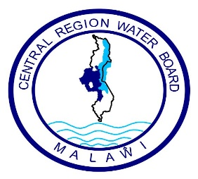

**Central Region Water Board**

**Request for Quotations (RFQ) for 100KVA TRANSFORMER**

1. The Central Region Water Board is inviting eligible bidders to Supply 100KVA Transformer through Request for quotations.
2. Interested eligible Suppliers must be registered with M.R.A, P.P.D.A and M.S.M.E and will be required to complete a set of Request for Quotations which can be downloaded from Central Region Water Board website
3. Sealed Bids must be delivered and deposited at CRWB head office **on or before 14.00 hours on Wednesday 29.03.2023 clearly marked with Request for Quotation for 100KVA Transformer** as indicated above**.**
4. Bids will be opened at **Central Region Water Board** on **Wednesday 29.03.2023** at **14.00 hours’ local time.** Late bids shall be rejected.
5. Central Region Water Board reserves the right to reject any or all bids and is not bound to accept the lowest or any other bidder.
6. Addresses for:
7. Clarifications**:**

**Attention: Mr. Simeon Banda - Procurement and Disposal Manager**

**Central Region Water Board Offices**

**Area 4, Murray Road**

**Opposite Immigration Offices**

**Private Bag 59**

**Lilongwe**

**Malawi**

**Phone No: 01 758 044 / 045/ 046**

**Cellphones: 0888 395 162 / 0998 570 437**

**Email:** [**crwb@crwb.org.mw**](mailto:crwb@crwb.org.mw) **/** [**sbanda@crwb.org.mw**](mailto:sbanda@crwb.org.mw)

1. **Submissions**

**Attention: Engineer John Makwenda – Chief Executive Officer**

**Central Region Water Board Offices**

**Area 4, Murray Road**

**Opposite Immigration Offices**

**Private Bag 59**

**Lilongwe**

**Malawi**

**Phone No: 01 758 044 / 045/ 046**

**Cellphones: 0881 707 535 / 0996 707 535**

**Email:** [**crwb@crwb.org.mw**](mailto:crwb@crwb.org.mw) **/** [**jmakwenda@crwb.org.mw**](mailto:jmakwenda@crwb.org.mw)